Service Specification No.
Service | CURE Programme: Tobacco addiction treatment pathway for inpatients
Commissioner Lead | Locality to complete with their lead commissioner details
Provider Lead | Locality to complete with their lead provider details
Period | TBC
Date of Review | TBC

1. Population Needs
  - National/GM context and evidence base

Greater Manchester (GM) published its cancer plan ‘Achieving World Class Cancer Outcomes: Taking Charge in Greater Manchester 2017-2021’, which clearly sets out programmes of work, from prevention to end-of-life care that taken together will transform cancer care for local patients.

The NHS planning guidance 2017–2019 published in September 2016 set out the ‘must dos’ for 2017-19 for every local system. In respect of cancer one of its main targets is reduction of smoking prevalence.

In response The Greater Manchester Health and Social Care Partnership’s tobacco control plan Making Smoking History, published in July 2017, has set ambitious targets for the health economy to reduce smoking rates across the health economy.

Achieving the tobacco control plan objectives will require a structured, multi-faceted approach including secondary care smoking cessation, which has also now been identified in the NHS Long Term Plan.

Inpatient data 17/18 across GM
The table below shows the top 10 reasons for admission across all GM hospitals in 17/18 (elective and non-elective):

Admission diagnosis | Number of Admissions | % | Rank
Pneumonia, unspecified organism | 999 | 3.5% | 1
Abdominal and pelvic pain | 715 | 2.5% | 2
Unspecified acute lower respiratory infection | 695 | 2.4% | 3
Pain in throat and chest | 687 | 2.4% | 4
Chronic ischemic heart disease | 558 | 1.9% | 5
Other chronic obstructive pulmonary disease | 492 | 1.7% | 6
Viral infection of unspecified site | 488 | 1.7% | 7
Acute upper resp infections of multiple and unsp sites | 487 | 1.7% | 8
Other sepsis | 486 | 1.7% | 9
Other disorders of urinary system | 479 | 1.7% | 10

These diagnoses accounted for 21.1% of the total admissions in this period and 15.2% (3,356) of them have could have been caused by / associated with smoking.

Wythenshawe Pilot
Rollout has begun with a launch of CURE at Wythenshawe hospital in October 2018. This is the flagship hospital leading this transformation funded pathway for Greater Manchester Cancer and the highest priority for improving the health of our local population. Greater Manchester Cancer has secured transformational health funds to help develop and implement this service across Greater Manchester.

The first wave of hospitals (NHS Trusts) that will be asked to rollout CURE will be:

1. The Royal Oldham Hospital (Pennine Acute Hospitals NHS Trust)
2. Fairfield General Hospital (Bury)
& Rochdale Infirmary (Pennine Acute Hospitals NHS Trust)
3. Salford Royal Hospital (Salford Royal NHS Foundation Trust)
4. Stepping Hill Hospital (Stockport NHS Foundation Trust)
5. Tameside General Hospital (Tameside & Glossop Integrated Care NHS Foundation Trust)
6. Royal Albert Edward Infirmary, Wigan (Wrightington, Wigan & Leigh NHS Foundation Trust)

Tobacco Addiction: The scale of the issue nationally

- Tobacco addiction is the single greatest cause of preventable death, disability, ill-health and social inequality
- Smoking causes 16 different forms of cancer and damages every organ in the body
- There are approximately 8 million smokers in the UK (2016 Office for National Statistics, Adult Smoking Habits)
- Half of all smokers will die prematurely of a smoking related illness & loose average of 10 years of life (Doll et al BMJ 2004, Pirie et al The Lancet 2013)
- Costs of smoking illnesses to the NHS (Public Health England 2015: Costs of Smoking to the NHS):
  - £850 million per year inpatient costs
  - £1.1 billion per year in primary care costs
  - £696 million per year in op secondary care service

Tobacco Addiction: The scale of the issue in ‘xx locality’

Locality specific data and statements to be included here – CURE team will provide some data which can be supplemented by locality data and narrative

The case for change

- Treating tobacco addiction is the single most cost effective lifesaving treatment provided by the NHS.
- The cost per life year gained of treating tobacco addiction is 1/25th the cost of statin therapy in patients with coronary artery disease
- The 2014 National Health Service Five Year Forward View highlights that a ‘focus on disease prevention is vital to managing costs and sustaining the long term viability of the NHS’.
- The newly published NHS Long Term Plan….
- The decline in smoking prevalence in the general UK population in recent decades is due to reduced uptake. The most immediate tobacco control imperative is helping active smokers to quit (Royal College of Physicians ‘Nicotine Without Smoke 2016)
- One in three smokers have made a quit attempt in the last year however in 2016-2017 less than 5% of smokers had access to stop smoking services (Smoking Toolkit Study 2018 & Office For National Statistics)
- The treatment of tobacco addiction is highly cost effective, even when modelling lowest quit rates (9%) and most expensive treatment (extended NRT £763 per person). Smoking cessation cost effectiveness is estimated at £634 per QALY (2018 NICE PHG94)

2. Outcomes
2.1 NHS Outcomes Framework Domains & Indicators

Domain 1 | Preventing people from dying prematurely | X
Domain 2 | Enhancing quality of life for people with long-term conditions | X
Domain 3 | Helping people to recover from episodes of ill-health or following injury
Domain 4 | Ensuring people have a positive experience of care | X
Domain 5 | Treating and caring for people in safe environment and protecting them from avoidable harm | X

2.2 Key Service Outcomes:

Formal pilot evaluation outcomes (based on Ottawa model):

- Mortality halved by 1 year - 11.4% vs 5.4%; p<0.001
- Mortality reduction at 2 years - 15.1% vs 7.9%; p<0.001
- Re-admission halved by 30 days - 13.3% vs 7.1%; p<0.001
- Re-admission reduced at 1 year - 38.4% vs 26.7%; p<0.001
- Increase quit rates at 6 months - 35% vs 20%

In 2016 2,654 patients registered at GP practices within the City of Manchester and recorded as current smokers were admitted to Wythenshawe Hospital. Therefore the potential impact of this service for City of Manchester residents admitted is as follows, if you apply the Ottawa outcomes to this set of data:
- 159 Saved admissions at 30 days
- 292 Saved admissions at 1 year
- 929 Successful quits
- 159 Lives saved in 1 year

Local Key Performance Indictors:

Number and % of adult patients admitted as In Patients (IP) with LOS > 1 day that have smoking status recorded. | Collect baseline | % to be set by the commissioner  Indicative = 90%
Number and % of smokers offered brief advice | Collect baseline | % to be set by the commissioner  Indicative = 90%
Number and % of smokers that are given NRT within 24 hours of admittance | Collect baseline | % to be set by the commissioner  Indicative 30%
Number and % of smokers referred to the CURE team | Collect baseline | % to be set by the commissioner  Indicative = 90%
​Number and % of smokers seen by the CURE team | ​Collect baseline | ​% to be set by the commissioner​  Indicative = 50%
Total number and % of smokers prescribed NRT ​ | Collect baseline | % to be set by the commissioner​  Indicative = 50%
​Total number and % of smokers prescribed varenicline | Collect baseline​ | % to be set by the commissioner​  Indicative = 20%
Number and % of smokers referred to the community stop smoking service | Collect baseline | % to be set by the commissioner  Indicative 35%
Number of 4 week quits from referral to community stop smoking service | Collect baseline | % to be set by the commissioner  Indicative 35%

3. Scope
3.1 Aims and objectives of service

The CURE project is a comprehensive secondary care treatment programme for tobacco addiction. At its heart is systematically identifying all active smokers admitted to secondary care and immediately providing nicotine replacement therapy for the duration of the admission. This is supplemented by a consultation with an expert tobacco addiction team to construct a long term treatment plan after discharge. The term ‘CURE’ has been specifically chosen to ‘medicalise’ tobacco addiction and move away from the stigma of a lifestyle choice to disease treatment.
There is strong evidence that secondary care represents a unique teachable moment when a smoker is admitted to hospital to seed the concept of a quit attempt and achieve successful long term abstinence. Data from Canada has demonstrated that comprehensive secondary care treatment programmes for tobacco addiction deliver immediate and highly significant reductions in admissions rates and mortality.

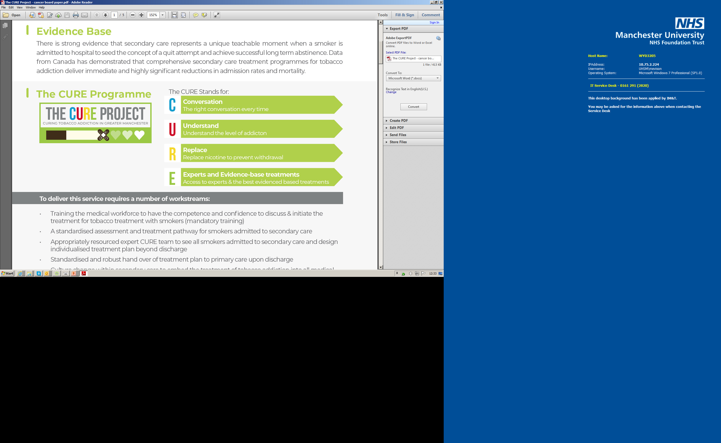

Aim

The aim of the CURE Programme is as follows:
- To deliver and demonstrate the immediate benefits of a comprehensive secondary care treatment programme for tobacco addiction, as seen in the Canadian population, in a UK population (in the first instance in 6 localities in Greater Manchester), supported by the gathering of appropriate data and evidence to support full evaluation and consideration of future funding options
- To accurately describe the volume of work, staffing requirements and pharmacotherapy requirements to provide a robust and successful service, in order to inform a wider Greater Manchester Implementation model and funding streams.
- Enable and support reporting of data and outcomes during 6-12month period to monitor achievement of outcomes which will inform each Providers business case for continuation of CURE as business as usual.
- Educate GPs, Commissioners, Public Health and Local Authorities on the importance and benefits across the healthcare system of a providing consistent treatment and support for Greater Manchester patients who smoke.

GM Objectives
- Train the medical workforce to have the competence and confidence to discuss & initiate the treatment for tobacco treatment with smokers (mandatory training)
- Develop and embed a standardised assessment and treatment pathway for smokers admitted to secondary care
- Appropriately resource the expert Specialist Nursing team to see all smokers admitted to secondary care and design individualised treatment plan beyond discharge
- Deliver a standardised and robust hand over of treatment plan to primary care upon discharge
- Support culture change within secondary care to embed the treatment of tobacco addiction into all medical teams day to day practice
- Develop IT systems to support the delivery of this programme

Local Objectives:
- Every health care professional is aware of the smoking status of every patient they care for
- Every health care professional has the competence and confidence to offer help to stop smoking through direct action and referral
- Every patient has access to the best available treatments and expert support to treat this disease

Localities can add others depending on their local tobacco strategy priorities

3.2 Service description/care pathway

Patient Pathway

CURE will contribute to the GM and locality ambition to reduce smoking prevalence by supporting smokers who are admitted to hospital to quit. All patients will be screened on admission and provided Very Brief Advice (VBA) and treatment by the admitting nurse or doctor. The CURE Specialist Team will then provide 1-2-1 quit support for all patients who smoke.

The service will include:

Admitting Team
- Complete Initial screening and assessment including brief advice by an within 6 hours (Brief advice will include 3 questions to determine the level of addiction)
- Offer treatment based on outcome of screening questions & prescribing protocol – providing rapid access to pharmacotherapy:
  - If the offer of NRT is accepted by the patient, the prescription for NRT will be given within 24 hours of admittance by nurses that are PGD trained
  - If admitting member of staff cannot prescribe they must ensure this is handed over to ward doctor or pharmacist

Specialist Nurse Team
- All patients identified as a smoker to be offered a 40 minute consultation (opt-out service) with a CURE nurse to develop a 1-2-1 treatment plan within the first 48 hours from the next working day
- Involvement of the nurse-led tobacco addiction team in devising a treatment plan for post discharge. Potential options:
  - Remaining on the CURE team caseload
  - Referral to the community stop smoking service and
  - GM telephone support line.
- A referral pathway to community stop smoking services for patients who are not on the CURE pathway.

Prescribing Protocol
- This should be linked to the level of addiction determined by the screening questions asked on admission.
- Prescribers should be aware of this protocol and it will need to be easily accessible as well as communicated effectively.
- Ward Pharmacists to be educated on this protocol and be able to advise admitting doctors/nurses.
- Ensure process in place that checks if appropriate medication has been prescribed on admission

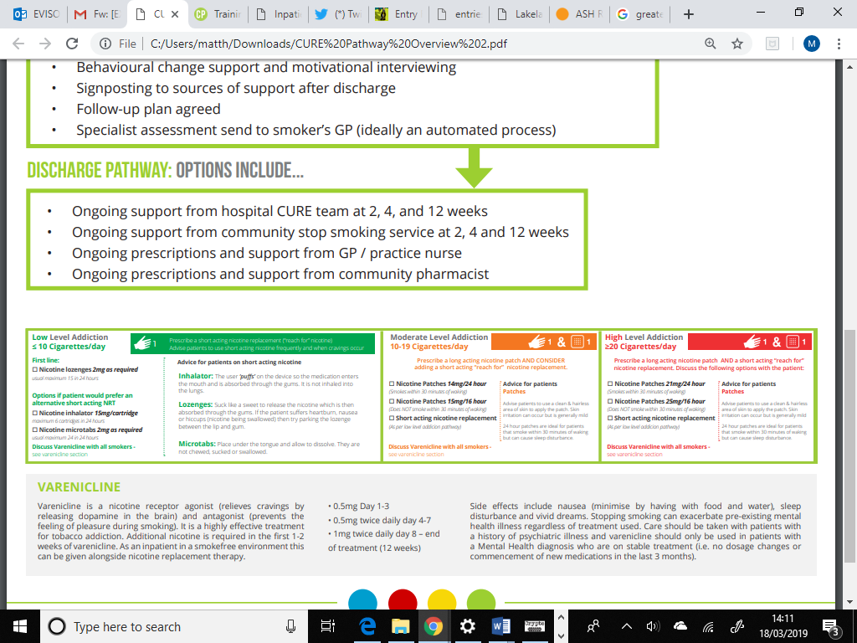

CURE Specialist Team

To ensure effective delivery of motivational interviewing, behavioral change support and expert advice to smokers during their inpatient admission requires a team of specialist tobacco addiction clinicians. This team will also
- Review the effectiveness of initial NRT prescriptions during their specialist consultation
- Ensure all available treatment options have been discussed and offered such as varenicline
- Oversee any specialist prescriptions such as bupropion

This service will need to be Nurse led.

Recruitment of staff for duration of transformation funding:

- To enable recruitment the Provider will support and administer the hospital recruitment process
- The Provider shall accommodate within the an existing hospital based team as well as enable access to appropriate equipment needed for the completion of their role.
- The Provider shall provide cross cover for the administrative role of Patient Navigator in instances where it is required for the duration of the pilot.

3.3 Service description/care pathway

The service will apply / not apply to the following:

In Scope | Out of Scope
Identification of smoking status for adults admitted to Wythenshawe Hospital | Assessment of patients on AE, DAYCASE, Paeds, Maternity
Initial assessment by parent team with NRT prescription for all patients. Specialist assessment & treatment by CURE team all IP’s with LOS >1day on admitting ward. | Identification, Assessment or treatment of Out Patients
Provision of inpatient & 7 days post discharge tobacco addiction pharmacotherapy | Provision of pharmacotherapy beyond 7 days post discharge.
Hospital delivery of pre-booked telephone follow-up (fu) appt 1-2 weeks post discharge with CURE team
Hospital delivery of face to face follow-up (fu) appt 4-6 weeks post discharge with CURE team for CO validation
Compliance with Tobacco CQUIN (parts 9a, b and c)
Delivery of supporting information to patients in line with projects delivered in scope of GM Tobacco Strategy.
Inform Primary Care of updated patient pathway | Pre-booked follow up appointments in Primary Care

Workstreams:

- Training the medical workforce to have the competence and confidence to discuss & initiate the treatment for tobacco treatment with smokers (mandatory training)
- A standardised assessment and treatment pathway for smokers admitted to secondary care
- An expert specialist tobacco addiction nursing team to see inpatient smokers and offer help/advice with medication choices as well as design individualised treatment plans for beyond discharge
- Standardised and robust hand over of treatment plan to primary care upon discharge
- Culture change within secondary care to embed the treatment of tobacco addiction into all medical teams day to day practice
- IT systems to support the delivery of this programme

Duration of transformation funding

This is a 12 month project following which the results will be evaluated and consideration be given to future funding arrangements.

3.4 Population covered

All patients admitted to xx who are smokers. Referrals will be made to community services according to the patients’ home address / registered GP.

3.5 Any acceptance and exclusion criteria and thresholds

This pathway is applicable to:
- Smokers
- Inpatients – admitted to a ward (not A&E)
- Adult – Localities to determine
- Excluding maternity

3.5 Interdependence with other services/providers

- Locality Population Health commissioner and lead for tobacco control
- GM Cancer CURE project team
- All hospital departments (apart from those identified as ‘out of scope’ above
- Community smoking cessation services
- Others to be defined in each locality

4. Applicable Service Standards
4.1 Applicable national standards (eg NICE)

PH48 - Implementing an Inpatient Stop Smoking Treatment Service in the secondary care setting
Recommendation 2 Identify people who smoke and offer help to stop
Recommendation 3 Provide intensive support for people using acute and mental health services
Recommendation 5 Provide information and advice for carers, family, other household members and hospital visitors
Recommendation 6 Advise on and provide stop smoking pharmacotherapies
Recommendation 7 Adjust drug dosages for people who have stopped smoking
Recommendation 8 Make stop smoking pharmacotherapies available in hospital
Recommendation 9 Put referral systems in place for people who smoke
Recommendation 10 Provide leadership on stop smoking support
Recommendation 11 Develop smokefree policies
Recommendation 12 Communicate the smokefree policy
Recommendation 13 Support staff to stop smoking
Recommendation 14 Provide stop smoking training for frontline staff

4.2 Applicable standards set out in Guidance and/or issued by a competent body (eg Royal Colleges)

Innovation in Medicine 2018: Providing smoking cessation for patients in hospitals will save lives and money

Royal College of Physicians (RCP) Report

4.3 Applicable local standards

To be determined in each locality

5. Applicable quality requirements and CQUIN goals
  - Applicable Quality Requirements (See Schedule xxx)

6. Location of Provider Premises
The Provider’s Premises are located at:

To be completed by each locality

7. Individual Service User Placement
Not applicable

7. Supporting documents

